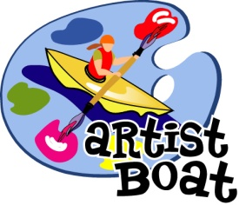
Artist Boat
2627 Avenue O, Galveston, TX 77550
Phone: (409) 770-0722 Fax: (409) 770-0712
www.artistboat.org info@artistboat.org

FOR IMMEDIATE RELEASE: August 31, 2015

Contact: Karla Klay, Executive Director
Email: kklay@artistboat.org
Phone: (409) 770-0722

Critical Wildlife Habitat Saved on Galveston Island
Galveston, TX – On Monday, August 31, 2015, Artist Boat finalized the purchase of 99 acres of Galveston Island coastal habitat from the Galveston Preserve at West Beach, Ltd., which is a partnership of the Texas General Land Office and MP Marquette, Galveston, LLC. With funding provided by the National Fish and Wildlife Foundation, and the strong cooperation of the sellers, Artist Boat was able to protect the tract from future development. This acreage is being added to Artist Boat’s Coastal Heritage Preserve, an initiative to protect a critical suite of wetland, tidal flat, coastal upland prairie, and open bay habitats on the west end of Galveston Island. The acquisition helps bring together, under single ownership and management, a total of 306 contiguous bayside acres to date, ensuring protection of these critical back-barrier island habitats in perpetuity.
Artist Boat’s acquisitions for the Coastal Heritage Preserve, and its implementation of habitat management measures, will ensure the long-term health of these habitats for wildlife. The habitats provide essential breeding, nesting, feeding, and cover for avian, upland, and aquatic species. These include protected migratory and endangered bird species, as well as commercially and recreationally important finfish and shellfish species. The previously planned development of this land would have been a major setback for the future of Galveston Island’s natural resources and the economic benefits they provide, as the development would have further fragmented the current habitats. Additionally, the development would have adversely impacted the water quality of West Galveston Bay and reduced flood surge buffering capacity.
Artist Boat is an environmental nonprofit dedicated to promoting the preservation and awareness of coastal margins and marine ecosystems through science and art.

