The Black Twig Borer Poses a Threat in East Texas Trees
Ronald Billings and John Warner
Texas A&M Forest Service

The forests of East Texas are attracting a variety of invasive pests. Laurel wilt, carried by the redbay ambrosia beetle, was recently detected in Hardin and Jasper counties. And the emerald ash borer, discovered last year in northern Louisiana, is knocking on the door, if not already here. Another pest from Asia, the black twig borer, has been here since at least the mid-1980s, but the damage it causes is just now becoming noticeable.
The black twig borer, with the scientific name Xylosandrus compactus, is a tiny ambrosia beetle barely 1/16 inch long. It bores into the thin twigs of over 220 trees and shrubs, including southern magnolia, grape, sweetgum, pecan, dogwood, water oak, red maple, redbud, grape and many other plants. Seemingly healthy trees are attacked. The first evidence of an infestation is a condition known as “flagging,” where scattered twigs throughout the tree’s crown wilt and die (see photos). Close examination of the dead twigs will reveal minute, circular holes (1/32 inch in diameter), usually on the underside of the dead twig. The adult beetles introduce a fungus which causes a black staining of the sapwood. Females begin laying eggs within the infested twig from spring through fall. The larvae or grubs hatching from the eggs feed on the white fungal “ambrosia” and also on the pith (center) of the twig. Pupation and mating of brood adults occurs within the infested twigs. The insects overwinter as adults, emerging through the entrance holes of the parent beetles and attacking trees most commonly in the spring when dogwoods bloom.
Curiously, males are unable to fly; they mate with females in the twig in which they were reared. Unmated females produce only male offspring. Studies at North Carolina State University have revealed that branches up to 7/8 inch may be infested with as many as 20 females. Fortunately, infestations of the black twig borer do not kill large, established trees, but cause unsightly damage to the crowns, of concern particularly on ornamental trees. Borer infestations may cause more serious damage or death to young or recently transplanted trees and shrubs. Light infestations in forest situations often go unnoticed and require no control. Wilting usually occurs just weeks after initial attack.
The black twig borer was first introduced into Florida from Asia in 1941. The beetle has been collected in traps in East Texas since at least 1987, as far south as Rockport. A current infestation on the Jones State Forest near Conroe has been observed in magnolia, red maple, black and sweetgum, red bay, white oak, water oak and other species. Symptoms of black twig borer infestations also have been noted this year near Orange, Beaumont, and Lufkin.
The preferred control on high-value ornamental trees is to prune out and destroy infested twigs. Flagged branches should be severed three to four inches above the pinhole (beetle entrance hole). Mulching, avoiding over-fertilization, watering during dry spells, and other practices to enhance tree health will make the trees less likely to be attacked. Chemical control using topical insecticide sprays is not recommended nor usually very effective.

Photos
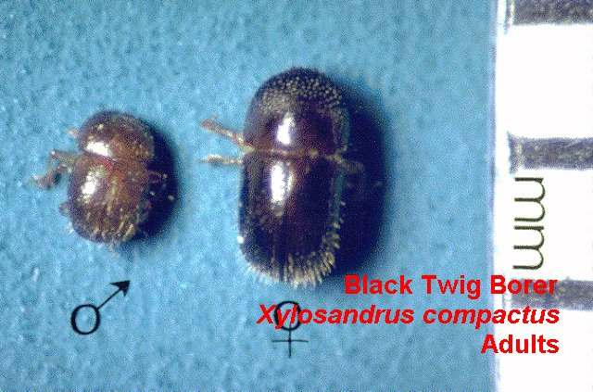
- Adult male (left) and female black twig borers (Photo courtesy North Carolina State University)
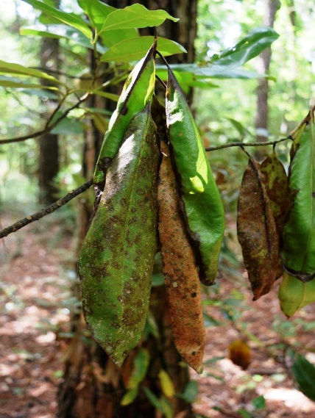
- Wilting of southern magnolia leaves, usually the first symptom of black twig borer attacks (Photo taken by John Warner in northern Montgomery County)
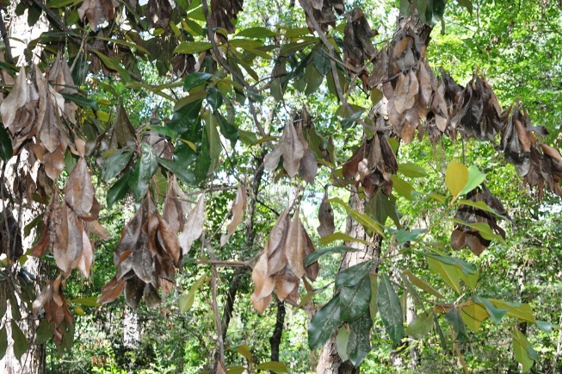
- Dead twigs on a southern magnolia infested by black twig borers, Jones State Forest (Photo by Ron Billings)
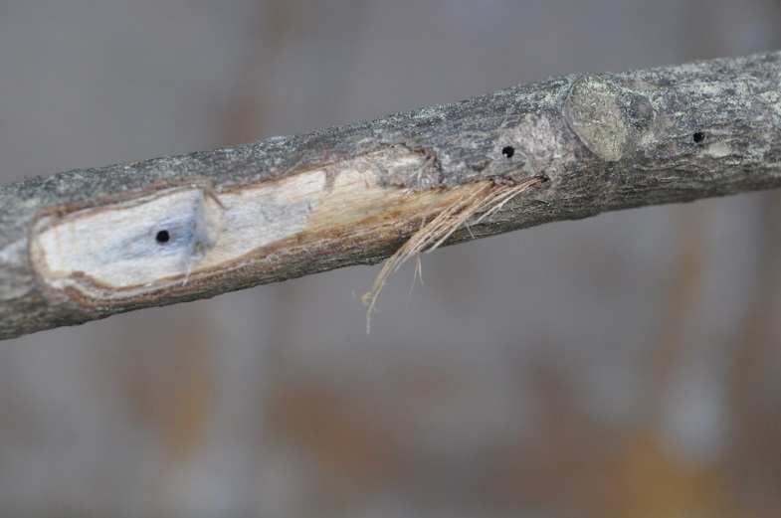
- Tiny entrance holes (1/32 inch in diameter) of black twig borer and associated staining of magnolia twig. (Photo by Ron Billings)

