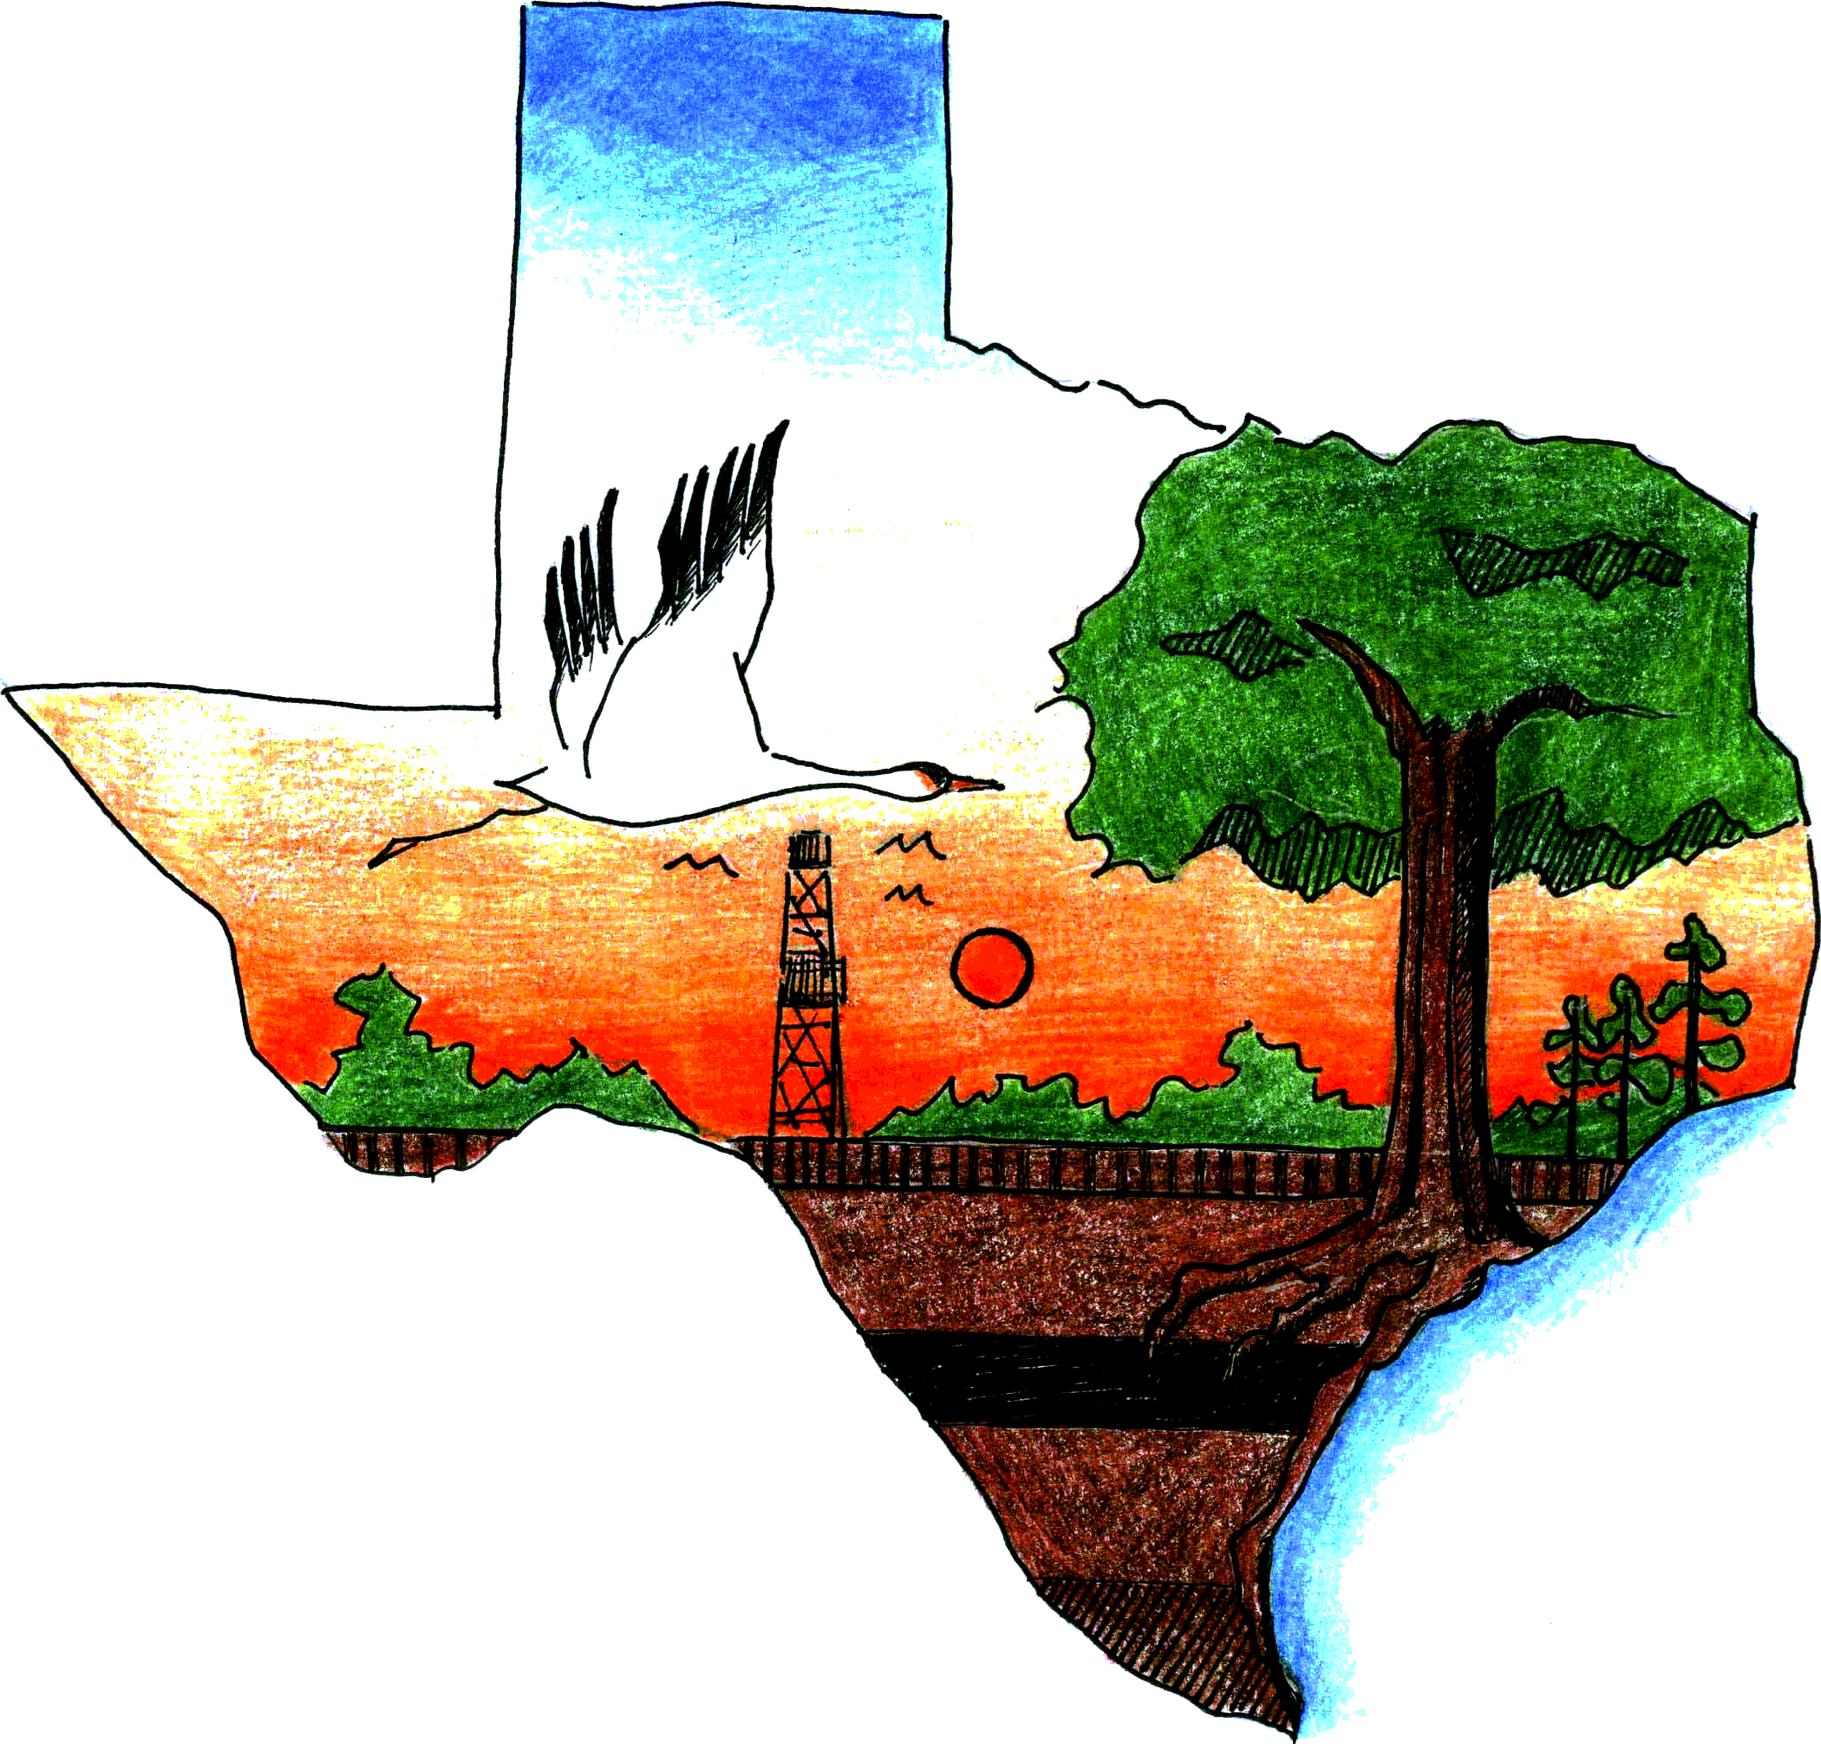
Texas Envirothon
University of Houston-Clear Lake
2700 Bay Area Blvd., MC 540
North Annex Office
Houston, Texas 77058-1098
(281) 283-3045

www.TexasEnvirothon.org

FOR IMMEDIATE RELEASE

Academy of Science and Technology from The Woodlands wins the 2014 Texas Envirothon
Houston, Texas, April 10, 2014—Academy of Science and Technology Team Alligator placed first at the Texas Envirothon which took place April 5–7, 2014, at the University of Houston-Clear Lake campus in Houston, Texas. Woodlands College Park Team 2 placed second, while Richardson High School Team C took third place.
Students on the winning team are Horatia Fang, Manasi Joshi, Colton Nettleton, Eleanor Shaul and Andie Tong. The team advisors are Linda Costanzo and Larry Walker.
Awards were given to the top scoring teams on the field exam by topic and for the top team in the oral presentation during a Monday afternoon ceremony at the University of Houston-Clear Lake. In Aquatics, The John Cooper School Team B and Richardson Team A tied for first place. Tied in Forestry were The Academy of Science and Technology Team A and Richardson Team C. The Academy of Science and Technology Team A took first place in Soils. Tied for first in Wildlife were Academy of Science and Technology Team C and Georgetown 4-H. The Current Issue winner was The John Cooper School Team A. J Frank Dobie Team Awesome won first in Oral Presentation. Two special awards were also presented—J Frank Dobie High School Team Awesome received the Extra Mile award and the Rookie Team award was presented to Georgetown 4-H for earning the top field test score among first-time team participants.
Twenty-one teams from 13 schools participated in the competition. Participating schools were Academy of Science and Technology, The Woodlands; The John Cooper School, The Woodlands; The Woodlands College Park High School, The Woodlands; Richardson High School, Richardson; South Grand Prairie High School, Grand Prairie; Harlingen South High School, Harlingen; Carroll Senior High School, Southlake; J Frank Dobie High School, Houston; Georgetown 4-H, Georgetown; St Thomas High School, Houston; Sam Houston High School, Arlington; Science Academy of South Texas, Mercedes; and Rio Hondo High School, Rio Hondo.
The fun began on Saturday afternoon with student training workshops offered by a variety of professionals. During the presentations, students received training in aquatics, forestry, soils, wildlife, and oral presentation skills. The hands-on portion of the training occurred at the Armand Bayou Nature Center, which included fish and invertebrate identification and a walking tour of the nature trails and restored prairie.
Presenters included John Boyette, Texas A&M Forest Service; Dennis Brezina, USDA-Natural Resources Conservation Service; Stephen Curtis and Jenny Oakley, Environmental Institute of Houston; Andy Sipocz, Texas Parks and Wildlife Department; Kathy Garland, University of Houston-Clear Lake; Michelle Holyfield and Alex Stanton, Eastman Chemical Company; AJ Vale and Jeff Hill, U.S. Fish and Wildlife Service; and James Rogers, Natural Resources Conservation Service.
The field competition began on Sunday morning at the University of Houston-Clear Lake in Houston, Texas. Ninety-nine students as well as 18 team advisors endured morning rain showers to complete the field test portion of the competition. Questions on the field test ranged from identifying animal skulls and aquatic invertebrates and taking tree measurements to describing soil textures and discussing sustainable local agriculture.
To help students prepare for Sunday evening’s challenge, which was to develop a presentation addressing how to best build a community sustainable food garden in a food desert with the City of Houston, Angela Chandler, education director and program manager for The Garden Academy, and Chris LaChance, director of education for Urban Harvest, gave presentations on the current issue topic—sustainable local agriculture/locally grown.
On Sunday evening, the students were sequestered for three hours to work on their presentations. The presentations were delivered to a panel of five judges on Monday morning.
More than 40 volunteers contributed over 170 volunteer hours while undertaking a variety of jobs that included monitoring the field stations, taking photographs, leading students to each station, grading the field tests and serving as judges for the oral presentations.
Sponsors of the 2014 Texas Envirothon were Access Midstream, Eastman Chemical Company, Enbridge, ExxonMobil Baytown, Entergy, the Jacob and Terese Hershey Foundation, GSI Environmental, Capital Farm Credit, Gulf Coast Waste Disposal Authority, JSC Federal Credit Union, Texas Association of Environmental Professionals, Environmental Institute of Houston, University of Houston-Clear Lake, Association of Texas Soil and Water Conservation Districts, Texas Association for Environmental Education, Reilly Realtors LLC, Harris County Soil & Water Conservation District, Montgomery County SWCD, Coastal Plains SWCD, Bowie County SWCD, Alamo SWCD, Walker County SWCD, Upshur Gregg SWCD, Armand Bayou Nature Center, Law Ranch Cattle Company, Moondog Farms, Natural Resources Conservation Service, North American Envirothon, Texas A&M AgriLife Extension Service, Texas A&M Forest Service, Texas Master Naturalists, Texas Parks and Wildlife Department, U.S. Fish and Wildlife Service, The Garden Academy and Urban Harvest.

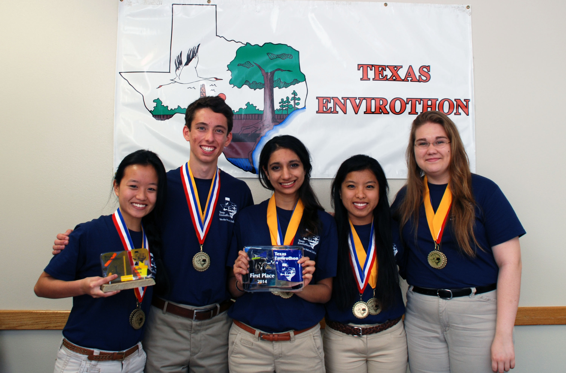
Academy of Science and Technology Team Alligator takes top honors at the 2014 Texas Envirothon held at the University of Houston-Clear Lake in Houston, Texas. Pictured (l. to r.) are Horatia Fang, Colton Nettleton, Manasi Joshi, Andie Tong and Eleanor Shaul.

ABOUT ENVIROTHON
Envirothon is an academic, extra-curricular environmental and natural resource education program and competition designed for high school students. Teams composed of five students answer questions focusing on five areas of study: aquatics, forestry, soils, wildlife, and the current environmental issue. In addition to the field experience, students also participate in an oral component focusing on a real-world environmental problem.

CONTACT
Wendy Reistle
Reistle@uhcl.edu
Environmental Institute of Houston
University of Houston-Clear Lake
2700 Bay Area Blvd., MC 540
North Annex Office
Houston, Texas 77058-1098
(281) 283-3045
www.TexasEnvirothon.org

###

